Setting up Google Analytics with ATG Blueprint
Author: Ian Davis

- Customer sets up Google Account
To use Google Analytics effectively, we need our customer to setup a Google Account into which the site analytics data will be collected. The reason we need our customer to do this is that Google imposes a 5 million page views per month limitation on Google Analytics per account, UNLESS the account is also an active Google AdWords account. Since it is highly likely that our customer’s have a Google AdWords account already, it should be no issue for them to create a new ‘Profile’ to represent the site.

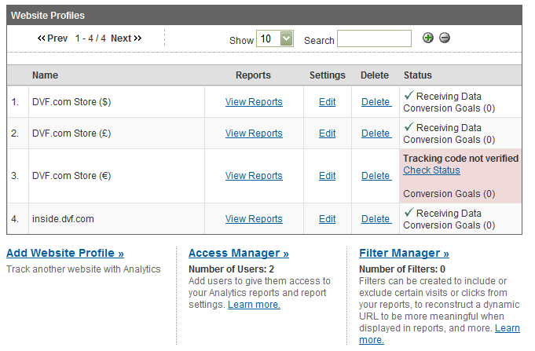
Having created the Profile, we require our customer to use Google’s ‘Access Manager’ tool to grant ATG access (with Administrator Access) to this profile, just so we can configure the Profile correctly. This can be down-graded to View-only Access once we’ve set some things up for the customer.
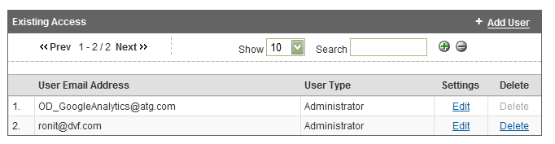

The customer should grant Administrator Access to our Google Account ID:

OD_GoogleAnalytics@atg.com

- Account Configuration
There are a few things that need to be configured in the Google Site Profile for it to work properly with an ATG Blueprint site.

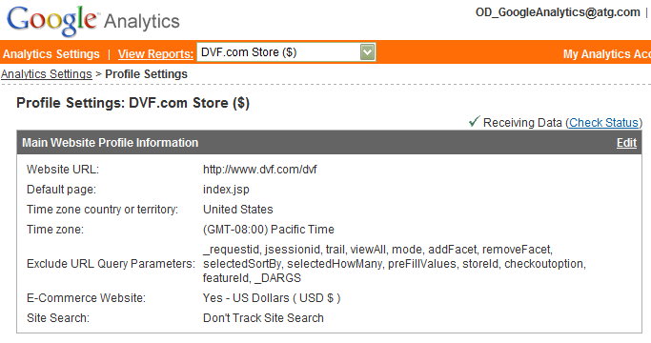

From the screen listing the Site Profiles for the Account, Click on ‘Edit’, and then click on ‘Edit’ to edit the ‘Main Website Profile Information’. Set the information as follows.

Website URL: Ensure this is the correct URL to the ATG site. Include the full path (Domain plus sub-directory) to where the home page is placed.

Default Page: Set this to ‘index.jsp’. This ensures that Google measure direct hits to the domain (without a page name) as a hit to the homepage.

Time Zone and Territory: This can be set as appropriate, but may not be editable if it has already been set as part of the customer’s Google AdWords setup.

Exclude URL Query Parameters: This is a list of query parameters that should be ignored by Google in order to ‘group’ page hits together, even though the list of query parameters may not be exactly the same. For Blueprint sites, we have found the following list of query parameters to exclude as:

_requestid, jsessionid, trail, trailSize, viewAll, mode, start, addFacet, removeFacet, selectedSortBy, selectedHowMany, preFillValues, storeId, checkoutoption, featureId, _DARGS, parentCategoryId, removeAllFacets, numResults, totPage, start

Ecommerce Website: Set this to ‘Yes’. This will ensure access to the eCommerce reports when browsing the site reports. Also set the currency as appropriate.

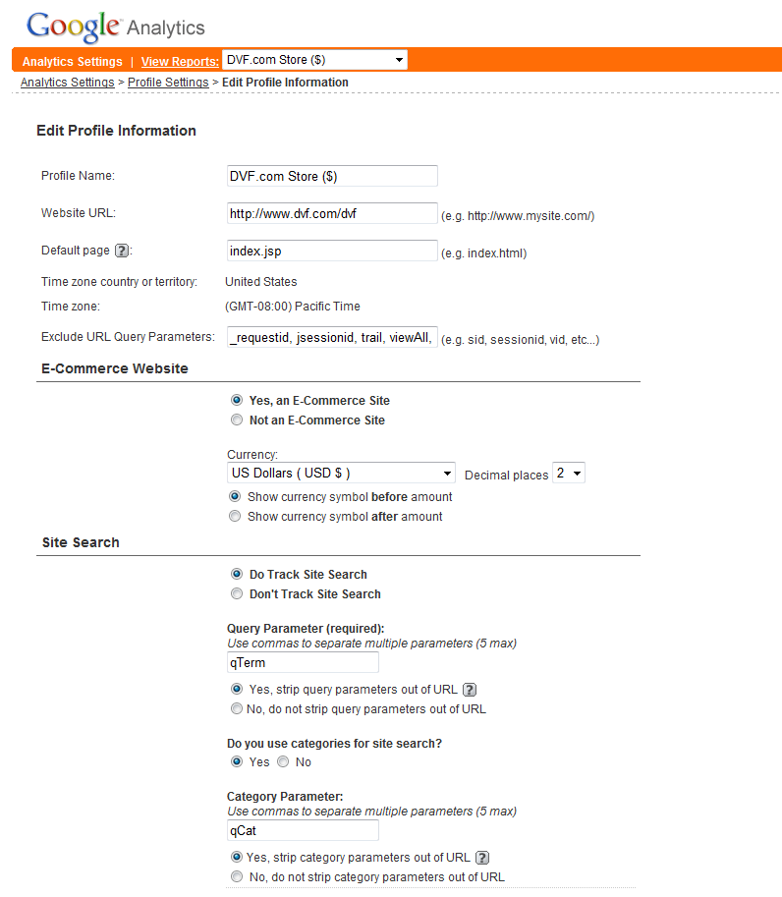

Do Track Site Search: Set this to ‘Yes’. Set the Query Parameter to ‘qTerm’ and set ‘Yes’, strip query parameter’. Set ‘Yes’ for using categories, set the Query Parameter to ‘qCat’ and set ‘Yes’, strip query parameter’.

Ensure that these changes are ‘Saved’ into the Profile.

- Using the ATG/Google Analytics integration code
For Google Analytics to function, it requires some JavaScript to be inserted into the web pages. Google Recommends that this script is placed at the end of a web page just before the </body> tag so that it is the last thing to execute on a page load.

The ATG/Google Analytics integration is a set of Simple JSP Tags. The main ‘beacon’ tag is used at the base of every page in the site, and is configured through a number of Media-Item entries in the Product Catalog repository.

- Placing the code

The googleBeacon.tag , googleEvent.tag and googleSegment.tag pages need to be inserted into the /WEB-INF/tags/bc2blueprint directory of your web application.

Edit the /WEB-INF/tags/b2cblueprint/pageContainer.tag file. This file should be amended to use the googleBeacon tag just before the page_end.jsp include, like this…

...
<dsp:include page="/navigation/gadgets/copyright.jsp" flush="true"/>
</div>
</div>

<cbp:googleBeacon
accountNumOverride=””
stripCommonQueryParams=””
orderAffiliation=”” />

<dsp:include page="/includes/page_end.jsp"/>

The passed attributes are optional, but are defined as:

accountNumberOverride forces the passed Google Account number to be used.

stripCommonQueryParams defaults to true, and removes many common Blueprint query parameters before the page URL is logged by Google Analytics

orderAffiliation is the ‘Affilation’ attribute used for Google Analytics’ eCommerce reporting, and allows the placed Order to be attributed to an Affiliate.
- Creating the repository entries

To function correctly, the ATG/Google integration code requires some entries in the Product Catalog’s media-internal-text. Configuring the integration using this approach has the advantage of being easily managed and maintained through the ATG Business Control Center by non-technical resources.

The solution functions by using a correctly named Media Folder and correctly named media-internal-text entries, and these are queried and used by the google_beacon.jsp file at run-time.

Firstly, a new Media Folder called ‘Google Analytics’ needs to be created in the Product Catalog Repository. This will be used to store the specific media-internal-text entries which makes the integration function correctly. (It doesn’t matter if this new Folder has a parent folder, or not)

Secondly, some media-internal-text items need to be added into this folder.

Item – ‘Enabled’
Text Data: ‘true’ or ‘false’

This item simply determines whether to render the Google JavaScript, or not.

Item – ‘Account’
Text Data: The account number to be used for collecting data. It will look something like ‘UA-1234567-1’

This item stores the Google Account number. If you are running a multi-site configuration (perhaps for different geographies or currencies), and have setup multiple Google Analytics Profiles (with different UA-??? numbers) to collect data, you can add additional entries for each ‘Store ID’. For example, you may leave the ‘Account’ entry as a catch-all, but have specific entries called ‘Account (store_us)’, ‘Account (store_eu)’, etc. so that you can vary the Google Account ID to be used.

Item – ‘Ignore Pages’ (Optional)
Text Data: Comma delimited list of page names to suppress the Google JavaScript rendering.

Item – ‘AdWords Code Snippet’ (Optional)
Text Data: Paste the code snippet that Google will provide you.

This item allows you to tie a successfully submitted Order in the storefront to a Google AdWords account. When you set up AdWords in Google, a code snippet will be provided to you. Cut and paste the snippet into the Text Data property. The code snippet will then be rendered whenever an Order is successfully placed.

NOTE: It is a good idea to deploy these repository items before the new application build (using the Google tags) is pushed to production so that the data is immediately available.

- Using Google’s Customer Segmentation
Google Analytics has a very rudimentary ability to set customer segmentation, and by no way matches the richness that ATG provides. Google only supports segmentation on a single dimension, so you must decide what dimension you want to analyse.

To facilitate how Google handles the Profile Groups provided ATG, you need to define a mapping between the two approaches.

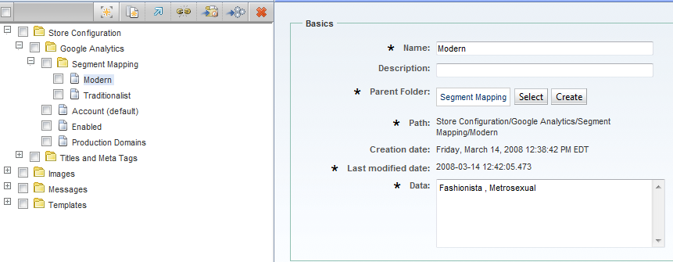

Under the ‘Google Analytics’ Media Folder, created a new Folder called ‘Segment Mapping’.

In this new folder, you can define Google Customer Segments by creating new media items where the properties represent:

Media Item Name – The name of the Google Customer Segment as will be reported into Google.
Media Item Text Data – A comma delimited list of one or more ATG Profile Groups which map to the Google Customer Segment.

As each page is rendered, the integration code will examine the User’s Profile Group membership, and if it is able to match one of these Profile Groups to a Google Segment, then the necessary JavaScript will be rendered.

In the above example, if the User is found to have ATG Profile Group membership to ‘Fashionista’ or ‘Metrosexual’, this fact will be represented to Google as the User being a customer segment of ‘Modern’.

NOTE: The integration code will only match on the first mapping it finds, so be careful not to duplicate ATG Profile Groups in more than one Google Customer Segment. If no match is found, then no Customer Segment JavaScript will be rendered.

As an alternative to the above described approach, you can use the googleSegment tag in your page code, and pass in a variable ‘gaSegment’ which is set to your required value, like this:
<cbp:googleSegment gaSegment="Fashionista" />

- Using Google’s Event Tracking (Beta)
Google Analytics is able to track on reports on Events that happen on your site. To do this, Google defines Events using the following terminology.

- Object – The ‘thing’ that an event happens to, like a ‘Video’ or an ‘Order’
- Action – The event that happened to the Object, like a ‘Play’ or a ‘Submit’
- Label – Optional, additional text to display about the Object, such as ‘Finding Nemo’
- Values – Optional, additional information about the event

The ATG Google Integration uses an in-built capability of ATG to store events information which is then processed by the googleBeacon tag.

As the googleBeacon tag is processed near the end of each page request, it determines if there are any Google Event to process. If there are, it inserts the appropriate JavaScript to communicate the event to Google Analytics as part of the rendering of the current page request.

To record an event to be communicated to Google Analytics, you can use the provided googleEvent tag in your JSP’s, and pass it the appropriate parameters, like this:

<cbp:googleEvent
gaObject="Video"
gaAction="Play"
gaLabel="Finding Nemo"
gaData="02/03/2008" />

Obviously, the literal strings above can set using a literal or an EL-style ${variable}.

gaObject and gaAction are mandatory. gaLabel and gaData are optional, and will default to Null.

- ATG’s Google Analytics Account Details

www.google.com/analytics
Login: OD_GoogleAnalytics@atg.com

ATG email group list
OD_GoogleAnalytics@atg.com
On occasion, Google will send emails and reports to this email distribution group.

